The Battle of Neighborhoods

Go out in Frankfurt/Main - Germany

Robert Juergens



# Open a new Restaurant

After an exhausting workday or simply trying to relax during a holiday visit, eventually one requires some refreshment. Some nice place to go out should always be welcome. Especially if hunger demands something nice to eat.

But if a new restaurant is to be opened, a few things need to be considered, as competition is to be expected.

* Is the selected part of town easily reached?
* How many competitors would there be?
* Any other attractions perhaps which might draw visitors of Frankfurt to that area?

## Neighborhoods

So the first thing is to look into detailed location information of all districts of Frankfurt. Public transportation, attractions and dine-in restaurants are of primary concern.

In order to obtain these information, a solid database has to be established.

## Obtaining required data

To be able to determine the boundaries of all the districts of Frankfurt/Main the data is downloaded from <http://www.offenedaten.frankfurt.de/dataset/frankfurter-stadtteilgrenzen-fur-gis-systeme> .

To allow for processing it is required to convert these data into a csv-format. To that end the data is imported into a tool, namely QGIS – <https://www.qgis.org> - , and exported as a csv-file.

The result is shown in Figure 1.



Figure

The first couple of rows of the corresponding Dataframe is depicted in Figure 2­.



Figure

The center of all districts are indicated with markers, as shown in Figure 3.



Figure

Retrieving location information from Foursquare allows to add markers for places of interest, shown around the main station of Frankfurt in Figure 4.



Figure

A few exemplary places of interest are listed as a dataframe. (see Figure 5)



Figure

Another step in identifying the type of all the venues, a sorted list of venue categories is obtained from the Foursquare data. (Figure 6)



Figure

## Finding a suitable neighborhood

Although the inhabitants of Frankfurt also love to go out, it is expected that more often visitors and people, presumably bankers, working in Frankfurt but living outside, want to find a dine-in restaurant

* In an attractive environment
* With public transport access
* And during fairs also a Hotel, preferably somewhere nearby

Therefore a choropleth map is showing these attributes in Figure 7. Here all overlays are active.



Figure

To distinguish the different layers figure 8 shows the districts with the most concentration of hotels and tram stations.

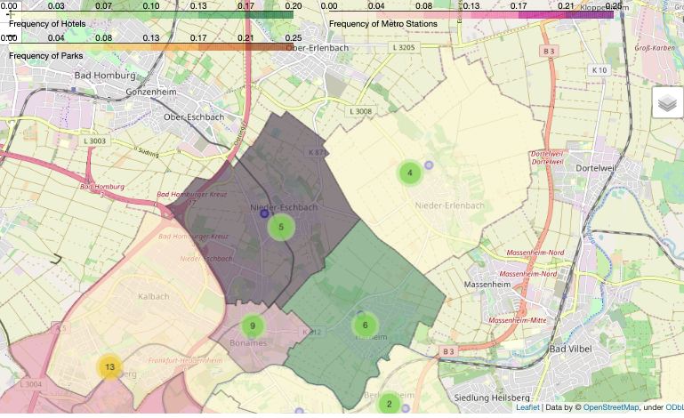

Figure

## Analysis

To open a new restaurant in Frankfurt, it is probably difficult to try it just where everybody else has already settled in. Perhaps competition is a nice thing, but finding a place in the ‘Altstadt’ with its high rents requires probably luck and a cunning business plan.

On the other hand there a quite a lot of regular fairs and other public events which draw a lot of visitors to Frankfurt, allowing the hotels a decent share of the income.

According to the analysis of the data it might be some good idea to look for a place in ‘Nieder-Eschbach’. It is located at the boundary of Frankfurt, has public transportations and hotels.

So after all the excitement, people might just want to relax in a more quite environment before retreating to their hotels.

Unfortunately ‘Nieder-Eschbach’ does not provide any attraction or parks. That interferes with the initial assumptions of the necessity of such things. But perhaps when looking into evening hours for going out, attractions might have a lesser priority.

It might be necessary, based on the insights obtained from the data, to learn how the booking situation of the hotels located in that district actually is. Depending on that a final decision might be sound.

## Conclusion

It is still difficult to offer an advice without going into further details. But at least the data provides clear insights of how the location of Hotels, public transportation and attractions are clearly distinguishable. And for a start ‘Nieder-Eschbach’ might be a good idea for a start, depending on the actual booking experiences of the hotels.